Chapter 13, Problem 14.

Obtain the Thevenin equivalent circuit for the circuit in Fig. 13.83 at terminals
a-b.

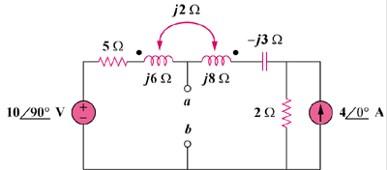

20∠0˚ A

50∠90˚ V

Figure 13.83
For Prob. 13.14.

